 

**FORTIUS FORTEVENT**

**WHAT IS HALL OF FRAME?**

* Teams of students will construct a frame-based structure.
* Structure will be judged on aesthetics and originality of design, presentation, ultimate load carrying capacity, height of structure (number of floors) and predicted failure point.
* The team will consist of maximum of 3 students.

**OBJECTIVE**

* Design a frame-based structure which has maximum height and which can carry maximum load with limited resources.

**REQUIREMENTS**

* Cardboard sheet(x1)
* Interior sheet(x3)
* Glue
* Scissor
* Newspapers

**SPECIFICATIONS OF FRAME**

* The base area should be at least 250mm x 250mm.
* Height of Ground Floor which is to be used as parking should be 120 +/- 10 mm
* Subsequent floor height should be 100mm with an error of +/- 10mm.
* The columns can be of any shape the team want. (i.e. rectangular, triangular, square).
* The number of columns should decrease with increase in number of floor.
* At every floor sheet will be must. (i.e. base then columns, then sheet then columns and again sheet and so on).

**RULES:**

* Teams will be given 5 minutes to make final changes in their structure before the testing, and once the changes are done, the structure will be tested.
* All teams have to make their model at the venue, no team will be allowed to bring their models prepared before.
* The dimensions of the structure will be measured and it will be made sure that the structure satisfies the given dimensions.
* The built structure will be analysed and points will be awarded according to judging criteria given.

**TEAM SPECIFICATION:**

* A team may consist of maximum 3 members.
* Students from different educational institutes can form a team.

**JUDGING CRITERIA**

The judging of the structure is based on 4 important criteria:

* Ultimate load carrying capacity + 35 points
* Height of structure (no of floors) + 30 points
* Aesthetics, originality of design, presentation + 25 points
* Artificial wind load applied on the structure + 10 points

----------------

100 Points

If two teams score same points then structure with lesser weight will be winner.

Note: for e.g. the team with maximum number of floors will be awarded 30 points and the one with the minimum number of floors will be awarded 10 points.

Others will be awarded points in between, using linear interpolation.

**TIME DURATION**

2 hours will be given to construct this model to teams

**SAMPLE STUCTURE**

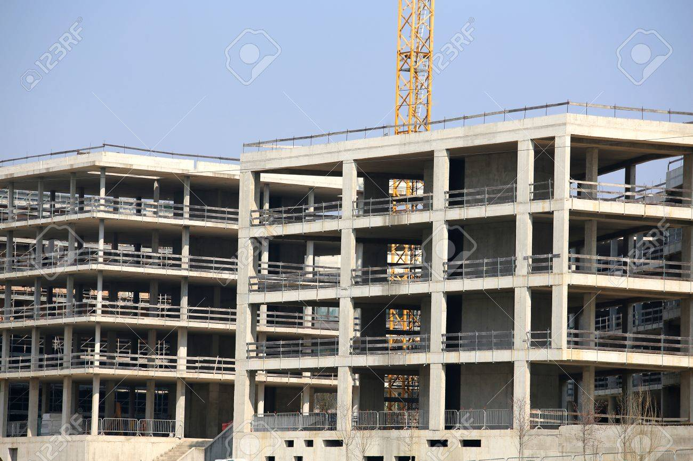

For queries

Coordinator:

* Mohammad Yasin Azimi Mobile number: 9173163826
* Mohammad Asjad
* Nisarg Joshi
* Rishi Agrawal